演 題：**Stretchable and Autonomous Self-Healing Semiconducting Polymers for Soft Organic Transistor Devices**

講 師：**Prof. Yu-Cheng Chiu**

Department of Chemical Engineering, National Taiwan University of Science & Technology

日 時：2024年10月4日（金）10:00~11:00

場 所：材料・化学棟　中会議室（MC102）

共 催：高分子学会北海道支部

Abstract:

To provide semiconducting polymers which possess both high electrical and mechanical properties for wearable electronics are quite challenging. Commonly, such rigid and high crystalline films of semiconducting channel are required to achieve high charge carrier mobility (>1 cm2 V-1 s-1) in the device, while to produce stretchable and mechanically robust materials demand for its low elastic modulus (<1 MPa) and ultrahigh deformability (>200% of strain). Due to this opposite nature, a rational design of novel stretchable and extra feature of self-healing polymeric semiconducting channels is essential. This report provides two effective ways, i.e., first by introducing chemical moieties to promote dynamic non-covalent crosslinking of the conjugated polymers and the second via simply physical blending of semiconducting polymers with mechanically soft, deformable, and self-healing elastomers. However, the relative low mobility issue hinders the progress of high-performance soft semiconductor. The perspective from our group for the issue will also be presented. As the results, fabricating a skin-inspired stretchable organic transistor that operates under deformations and mimicking the tear resistance and healable property of human skin can be expected in a wearable device.

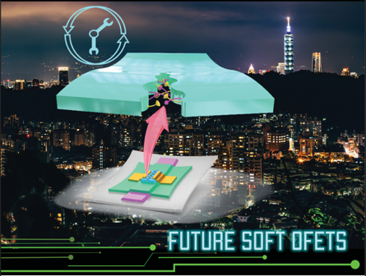

連絡先：工学研究院応用化学部門 磯野　拓也（内線：2290）